POLLUTION RISK FORECASTING & AIR QUALITY INTELLIGENCE
Student Name , Id : Vinay - 23341A4233
Student Name , Id : Rajesh - 23341A05E7
Student Name , Id : Bhanu Prakash - 23341A12A5
Student Name , Id : Jaswanth - 23341A4247
Batch: Aarambh
Project: Predicting PM2.5 concentration using Random Forest, Gradient Boosting and XGBoost
Dataset: air_quality_dataset.csv

1. Introduction
This document explains the Pollution Risk Forecasting & Air Quality Intelligence analysis. I have included not only what I found from the CSV, but also how I approached the work in my Jupyter Notebook. My aim is to explain it naturally: what the columns mean, why I cleaned certain values, why I engineered new features, why I compared the models I did, what the results tell me, and how I converted the output into a usable risk category.

2. Understandings about the Dataset
The CSV has 500 rows and 14 columns, with no missing values. I treat one row as one air-quality reading — a snapshot of pollutant concentrations and weather conditions at a monitoring site, along with the site's location type and recorded pollution source.

Column | Meaning in my words | Data type | Connection to analysis
PM2.5 | Fine particulate matter reading — the value we are trying to predict | Numeric (target) | Regression target; converted into the final risk category
PM10 | Coarser particulate matter reading | Numeric | Strong predictor; correlates closely with PM2.5
NOx | Nitrogen oxides concentration | Numeric | Predictor; cleaned for invalid negative values
NO2 | Nitrogen dioxide concentration | Numeric | Predictor; cleaned for invalid negative values
SO2 | Sulfur dioxide concentration | Numeric | Predictor; cleaned for invalid negative values; highest linear correlation with PM2.5
VOCs | Volatile organic compounds concentration | Numeric | Predictor
CO | Carbon monoxide concentration | Numeric | Predictor
CO2 | Carbon dioxide concentration | Numeric | Predictor; turned out to be the single most important feature in the final model
CH4 | Methane concentration | Numeric | Predictor
Temperature | Recorded ambient temperature | Numeric | Weather predictor
Humidity | Recorded relative humidity | Numeric | Weather predictor; negatively correlated with PM2.5
Wind_Direction | Wind direction in degrees (0–359°) | Numeric (circular) | Re-engineered into sine/cosine components before modeling
Location_Type | Urban, Industrial, or Rural monitoring site | Categorical | One-hot encoded; strongest categorical predictor
Source_Label | Recorded pollution source label | Categorical | Dropped — duplicated Location_Type

3. Relationships Between Columns
- PM2.5 is the target, and it is expected to move together with the other pollutants (PM10, NOx, NO2, SO2, VOCs, CO, CO2, CH4), since they tend to be co-emitted from similar sources.
- Location_Type is connected to almost every pollutant column, since Industrial sites tend to run higher and Urban sites tend to run cleaner in this dataset.
- Source_Label turned out to be a near-duplicate of Location_Type rather than independent information.
- Wind_Direction can be transformed into sine and cosine components for use in modeling, since it is a circular quantity.
- Temperature and Humidity are weather variables that may indirectly affect how pollutants disperse or accumulate.
- NOx, NO2, and SO2 are expected to be non-negative by definition, so any negative values indicate a data-quality issue rather than a real reading.

4. Initial Data Inspection
Before cleaning anything, I first wanted to know what I actually had. I inspected the shape, sample rows, data types, missing values, and summary statistics. This prevented me from making cleaning decisions blindly.
- Rows: 500
- Columns: 14
- Missing values across all columns: 0
- Negative values found in: NOx, NO2, SO2 (physically impossible for a concentration)
- Source_Label found to duplicate Location_Type
- PM2.5 range: roughly 10.8 to 127.6, mean ≈ 54.7
The main fields I paid attention to were the nine pollutant concentrations, the three weather/wind readings, and the two categorical columns describing site type and source.

5. Cleaning Decisions

5.1 Redundant column
Source_Label was found to be essentially a duplicate of Location_Type. I dropped it rather than keep two columns carrying the same information.
df = df.drop(columns=["Source_Label"])
My understanding: this removes the redundant column so the model isn't given the same signal twice.

5.2 Negative pollutant values
NOx, NO2, and SO2 contained a small number of negative values, which is not physically possible for a pollutant concentration. I did not drop these rows, since the rest of each reading is still useful — instead I clipped the negative values to a minimum of 0.
for col in ["NOx", "NO2", "SO2"]:
df[col] = df[col].clip(lower=0)
My understanding: this corrects the impossible negative values without discarding the rest of the reading.
My main cleaning principle
I tried to correct actual data-quality problems (impossible values, duplicate columns) without destroying information that could represent a genuine reading.

6. Preprocessing and Feature Engineering
After the basic cleaning, I prepared the dataset for modeling. The purpose was to make the categorical and circular information usable by the regression models without distorting its meaning.

6.1 Encoding the categorical column
Location_Type (Urban / Industrial / Rural) is text, so it needed to be converted into numeric columns. One-hot encoding creates a separate 0/1 column for each category, using Industrial as the reference level.
df = pd.get_dummies(df, columns=["Location_Type"], drop_first=True)
My understanding: this turns the site-type text into numeric columns the models can actually use.

6.2 Circular encoding of wind direction
Wind_Direction is measured in degrees (0–359°), which is a circular quantity — 359° and 1° are numerically far apart but physically adjacent. Converting it into sine and cosine components fixes this.
df["Wind_dir_sin"] = np.sin(np.deg2rad(df["Wind_Direction"]))
df["Wind_dir_cos"] = np.cos(np.deg2rad(df["Wind_Direction"]))
df = df.drop(columns=["Wind_Direction"])
My understanding: this represents wind direction correctly so that a value near 360° is not treated as far away from a value near 0°.
This is preprocessing rather than a change to the underlying business meaning of the data — I am mainly creating a cleaner structure so the models can use every feature consistently.

7. Exploratory Data Analysis
Before modeling, I wanted to see the shape of the target variable and how it relates to the other features.

7.1 Target distribution
Question: How is PM2.5 distributed across the dataset?
plt.figure(figsize=(7,4))
sns.histplot(df["PM2.5"], kde=True, bins=25)
plt.title("Distribution of PM2.5")
plt.show()
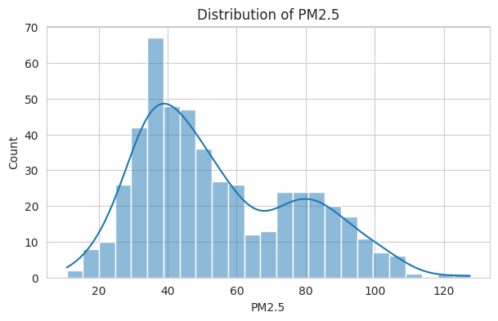
Figure 1 — Distribution of PM2.5 across the dataset.
Observation: The distribution is right-skewed with a primary peak around 35–40 µg/m³ and a smaller secondary bump around 75–85 µg/m³, which suggests the data may blend two underlying populations (e.g. cleaner and more polluted site types) rather than a single normal distribution.

7.2 Correlation analysis
Question: Which features are most strongly related to PM2.5, and to each other?
plt.figure(figsize=(10,7))
corr = df.corr(numeric_only=True)
sns.heatmap(corr, annot=True, fmt=".2f", cmap="coolwarm")
plt.title("Correlation Heatmap")
plt.show()

corr["PM2.5"].sort_values(ascending=False)
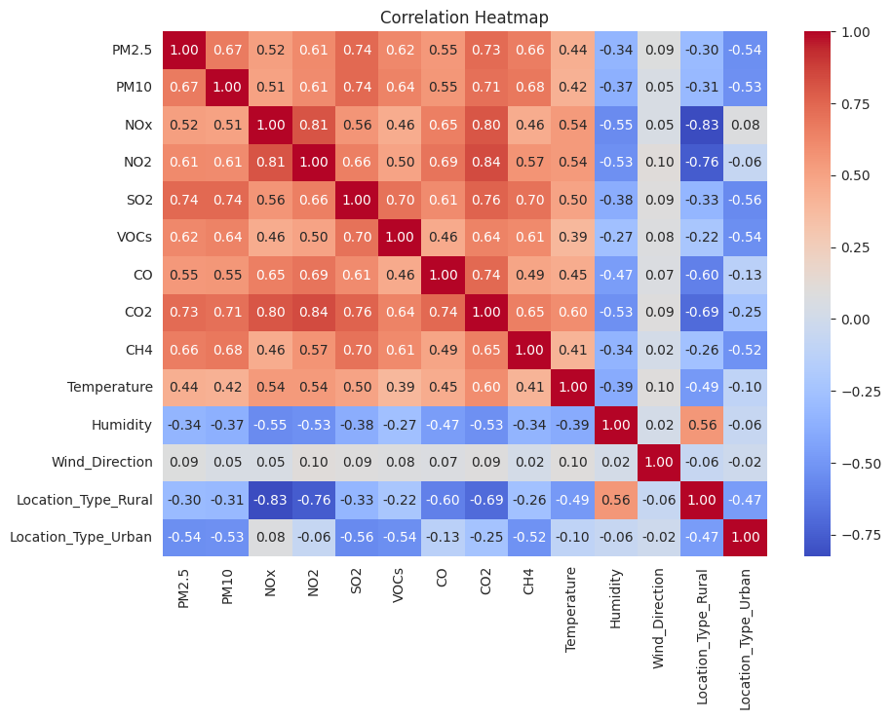
Figure 2 — Correlation heatmap of all numeric features.
Output (Pearson correlation with PM2.5, strongest to weakest): SO2 0.740, CO2 0.731, PM10 0.670, CH4 0.664, VOCs 0.621, NO2 0.610, CO 0.550, NOx 0.517, Temperature 0.443, Wind_Direction 0.085, Location_Type_Rural −0.302, Humidity −0.337, Location_Type_Urban −0.539.
Observation: SO2, CO2, PM10, and CH4 show the strongest positive linear correlation with PM2.5, while Humidity and Urban location show a negative correlation — consistent with industrial pollutant co-emissions tracking together, and Urban sites in this dataset trending cleaner than Industrial ones. NOx and Location_Type_Rural are also very strongly correlated with each other (−0.83), which hints at some multicollinearity among the predictor features.

8. Model Training and Comparison

8.1 Train/test split
The data was split into training (400 records) and test (100 records) sets using an 80/20 split, with a fixed random_state for reproducibility.
X = df.drop(columns=["PM2.5"])
y = df["PM2.5"]

X_train, X_test, y_train, y_test = train_test_split(
X, y, test_size=0.2, random_state=42
)
My understanding: this keeps a portion of the data completely unseen during training, so the evaluation reflects genuine generalization.

8.2 Baseline model
A plain Linear Regression is trained first as a baseline that the ensemble models are expected to beat.
lr = LinearRegression()
lr.fit(X_train, y_train)
lr_preds = lr.predict(X_test)
My understanding: this gives me a simple point of comparison before trying more complex models.
Output: Linear Regression -> RMSE: 13.40, MAE: 10.13, R2: 0.683

8.3 Ensemble models
The three required ensemble models are trained next, each with 200 estimators and default hyperparameters — no tuning applied at this stage.
rf = RandomForestRegressor(n_estimators=200, random_state=42)
rf.fit(X_train, y_train)

gbr = GradientBoostingRegressor(n_estimators=200, random_state=42)
gbr.fit(X_train, y_train)

xgb = XGBRegressor(n_estimators=200, random_state=42)
xgb.fit(X_train, y_train)
My understanding: this trains all three ensemble methods under the same conditions so the comparison in the next step is fair.

8.4 Comparing all models
A small helper function computes RMSE, MAE, and R² for each model's predictions, sorted by RMSE.
results_df = pd.DataFrame([
evaluate("Linear Regression", y_test, lr_preds),
evaluate("Random Forest", y_test, rf_preds),
evaluate("Gradient Boosting", y_test, gbr_preds),
evaluate("XGBoost", y_test, xgb_preds),
]).sort_values("RMSE")
Model | RMSE | MAE | R²
Linear Regression (baseline) | 13.40 | 10.13 | 0.683
Random Forest | 13.85 | 10.98 | 0.661
Gradient Boosting | 13.60 | 10.89 | 0.673
XGBoost | 14.53 | 11.26 | 0.627

Observation: The untuned ensemble models did not outperform the Linear Regression baseline by a wide margin here — all four sit in a similar RMSE range (13.4–14.5).

8.5 Selecting the best model
Among the three ensemble models specifically (Linear Regression is only the baseline), the one with the lowest RMSE is picked for further analysis.
best_name = tree_results.iloc[0]["Model"]
best_model, best_preds = candidates[best_name]
Output: Best performing model: Gradient Boosting (RMSE 13.60, MAE 10.89, R² 0.673), ahead of Random Forest (RMSE 13.85) and XGBoost (RMSE 14.53).

9. Feature Importance
Question: Which inputs actually drive the Gradient Boosting model's predictions?
importances = pd.Series(best_model.feature_importances_, index=X.columns)
importances = importances.sort_values(ascending=False)

plt.figure(figsize=(8,5))
sns.barplot(x=importances.values, y=importances.index)
plt.title(f"Feature Importance ({best_name})")
plt.show()
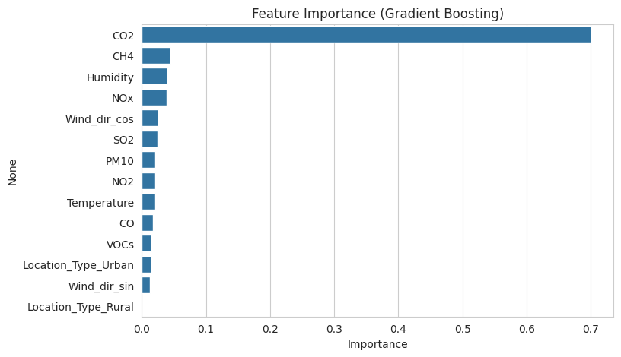
Figure 3 — Feature importance from the Gradient Boosting model.
Observation: CO2 dominates the model's decisions by a wide margin (importance ≈ 0.70), far ahead of the next tier — CH4, Humidity, and NOx. This is notable because CO2 was only the second-highest feature by raw linear correlation — the model is picking up a stronger non-linear relationship between CO2 and PM2.5 than a simple correlation coefficient can capture.

10. Risk Classification
The regression output is a raw PM2.5 number, which I convert into a readable risk category using standard breakpoints. This is the actual "risk forecasting" deliverable of the project.
def pm25_to_risk(pm25):
if pm25 <= 30: return "Good"
elif pm25 <= 60: return "Moderate"
elif pm25 <= 90: return "Poor"
else: return "Severe"
My understanding: this turns a raw number into a category that is easier for a non-technical reader to act on.
The breakpoints used:
PM2.5 Range (µg/m³) | Risk Category
0 – 30 | Good
30.01 – 60 | Moderate
60.01 – 90 | Poor
Above 90 | Severe

Applying this to the test set predictions gives the following sample (first 10 of 100 test rows):
Actual PM2.5 | Predicted PM2.5 | Predicted Risk | Actual Risk
26.55 | 41.57 | Moderate | Good
35.96 | 36.00 | Moderate | Moderate
34.24 | 36.68 | Moderate | Moderate
84.23 | 81.23 | Poor | Poor
57.06 | 42.10 | Moderate | Moderate
43.50 | 34.51 | Moderate | Moderate
16.12 | 38.51 | Moderate | Good
43.77 | 35.47 | Moderate | Moderate
76.62 | 85.32 | Poor | Poor
55.67 | 44.66 | Moderate | Moderate

Observation: Most predictions land in the correct risk band, including both Moderate and Poor cases. Two borderline cases in this sample (actual 26.55 and 16.12, both truly Good) were predicted one band higher, as Moderate — a reminder that risk-band accuracy near a breakpoint can look worse than the underlying regression error actually is.

11. Key Insights
The following statements are drawn directly from the results above so that they are evidence-based rather than guessed.
- Gradient Boosting is the best-performing model of the three ensembles tested, though only marginally ahead of Random Forest and the Linear Regression baseline.
- CO2 is by far the strongest driver of predicted PM2.5 in the chosen model, followed at a distance by CH4, Humidity, and NOx.
- SO2, CO2, PM10, and CH4 have the strongest simple (linear) correlation with PM2.5, while Humidity and Urban location correlate negatively with it.
- None of the four models explain more than about 68% of the variance in PM2.5 (R² ≈ 0.63–0.68), so a meaningful share of PM2.5 variation is not captured by the current features.
- Risk-category mismatches in the test set occur mainly for readings sitting close to a breakpoint (e.g. near 30 µg/m³), not for readings that are clearly Good or clearly Poor.

12. Recommendations
Recommendations follow from the evidence above rather than from assumptions.
1. Prioritize CO2 monitoring: since it is the dominant driver in the chosen model, ensuring CO2 sensors are well-calibrated will matter more to forecast quality than any other single input.
2. Treat borderline risk readings with caution: predictions near a breakpoint (e.g. 25–35 µg/m³) should be flagged for review rather than acted on automatically, since a small error there can flip the risk category.
3. Invest in hyperparameter tuning before deployment: the untuned ensemble models barely beat the Linear Regression baseline, so there is likely headroom to improve RMSE with tuning.
4. Collect more features if possible: since even the best model leaves roughly a third of PM2.5 variance unexplained, additional inputs (e.g. traffic counts, seasonal indicators) could help.
5. Re-validate the negative-value cleaning periodically: if NOx, NO2, or SO2 continue to show negative readings in new data, it may indicate a sensor or upstream data issue worth investigating rather than only clipping the symptom.

13. Project Conclusion
This project followed a complete workflow: dataset understanding, inspection, cleaning, preprocessing, exploratory analysis, model comparison, feature interpretation, and risk classification.

What was achieved
- The dataset structure and each column's role were documented.
- A redundant column and invalid negative values were identified and corrected.
- Location type was one-hot encoded and wind direction was re-engineered into sine/cosine components.
- Four regression models were trained and compared on a held-out test set.
- The best model's feature importances were extracted and interpreted.
- Predictions were converted into a four-level risk category matching standard PM2.5 breakpoints.

Limitation
No hyperparameter tuning was applied to any of the ensemble models, so the reported RMSE/MAE/R² values likely understate what these models could achieve. The dataset is also limited to 500 records from what appears to be a single source, so it is unclear how well the model would generalize to other monitoring stations or time periods.
14. Visualization and Why I Chose Each Chart
I did not treat visualization as decoration — each chart is meant to answer a specific question, with an observation recorded underneath it.
Chart | Question answered | My interpretation approach
PM2.5 distribution – histogram | How is the target variable distributed? | A histogram with a KDE overlay shows the shape, skew, and any multi-modal pattern in PM2.5 at a glance.
Correlation heatmap | How strongly are numerical variables related to PM2.5 and each other? | A heatmap makes many pairwise relationships easy to scan in one view, including multicollinearity between predictors.
Feature importance – bar chart | Which features actually drive the best model's predictions? | A horizontal bar chart ranks features clearly, which a table of numbers alone would not communicate as quickly.

15. Analysis Results
- Best-performing model: Gradient Boosting (RMSE 13.60, MAE 10.89, R² 0.673).
- Most important feature: CO2 (importance ≈ 0.70 in the Gradient Boosting model).
- Strongest linear correlation with PM2.5: SO2 (r = 0.740).
- PM2.5 range in the dataset: approximately 10.8 to 127.6 µg/m³ (mean ≈ 54.7).
- Risk categories used: Good (0–30), Moderate (30.01–60), Poor (60.01–90), Severe (above 90).
The important interpretation is that the feature with the strongest simple correlation (SO2) is not the same as the feature the final model relies on most heavily (CO2) — which is why I looked at both correlation and model-based feature importance rather than either one alone.

